SHREE CHANAKYA EDUCATION SOCIETY’S


INDIRA COLLEGE OF ENGINEERING AND MANAGEMENT
Approved By AICTE New Delhi, DTE (MS) and Affiliated to Pune University (Id-No. PU/PN/Engg/282/2007)

Ref. No.: ICEM/Jan2025 Date: /09/2025

One Page Report on “International Yoga Day Celebration” 2025

Date: 21st June 2025
Venue: MPH hall
Time: 9:00 PM

Brief Report:

Report on International Yoga Day Celebration 2025
The International Yoga Day Celebration 2025 was organized by Indira College of Engineering and Management, Parandwadi, Pune, on 21st June 2025 in the college premises. The event aimed to promote physical, mental, and spiritual well-being among students and faculty through the practice of yoga.
The program commenced at 9:30 AM with a warm welcome to all participants, followed by the lighting of the lamp and a brief address by Principal Dr. Nilesh Uke, who emphasized the importance of yoga in maintaining a healthy lifestyle and managing stress in the modern world.
A certified Yoga Instructor guided the session, introducing participants to various asanas (postures), pranayama (breathing exercises), and meditation techniques. Students and faculty members actively participated with great enthusiasm. The instructor also explained the health benefits and scientific significance of each posture, reinforcing the holistic approach of yoga towards well-being.
The event concluded with a group meditation session, spreading an atmosphere of peace and positivity across the campus. Certificates of participation were distributed to encourage students to continue practicing yoga regularly.
The celebration successfully reflected the global spirit of “Yoga for Harmony and Peace”, inspiring everyone to adopt yoga as a part of their daily routine for a balanced lifestyle.

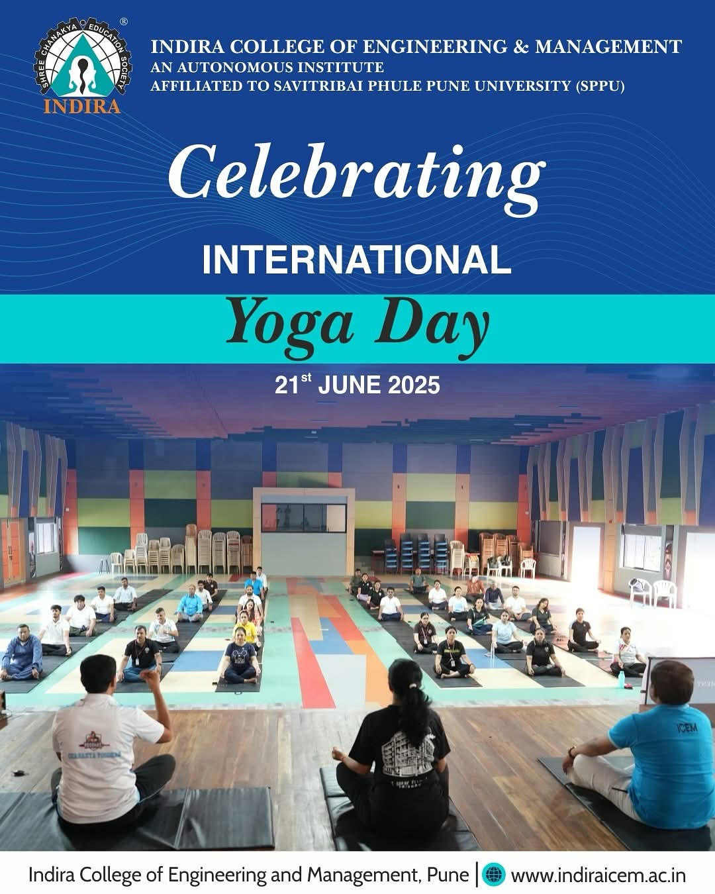
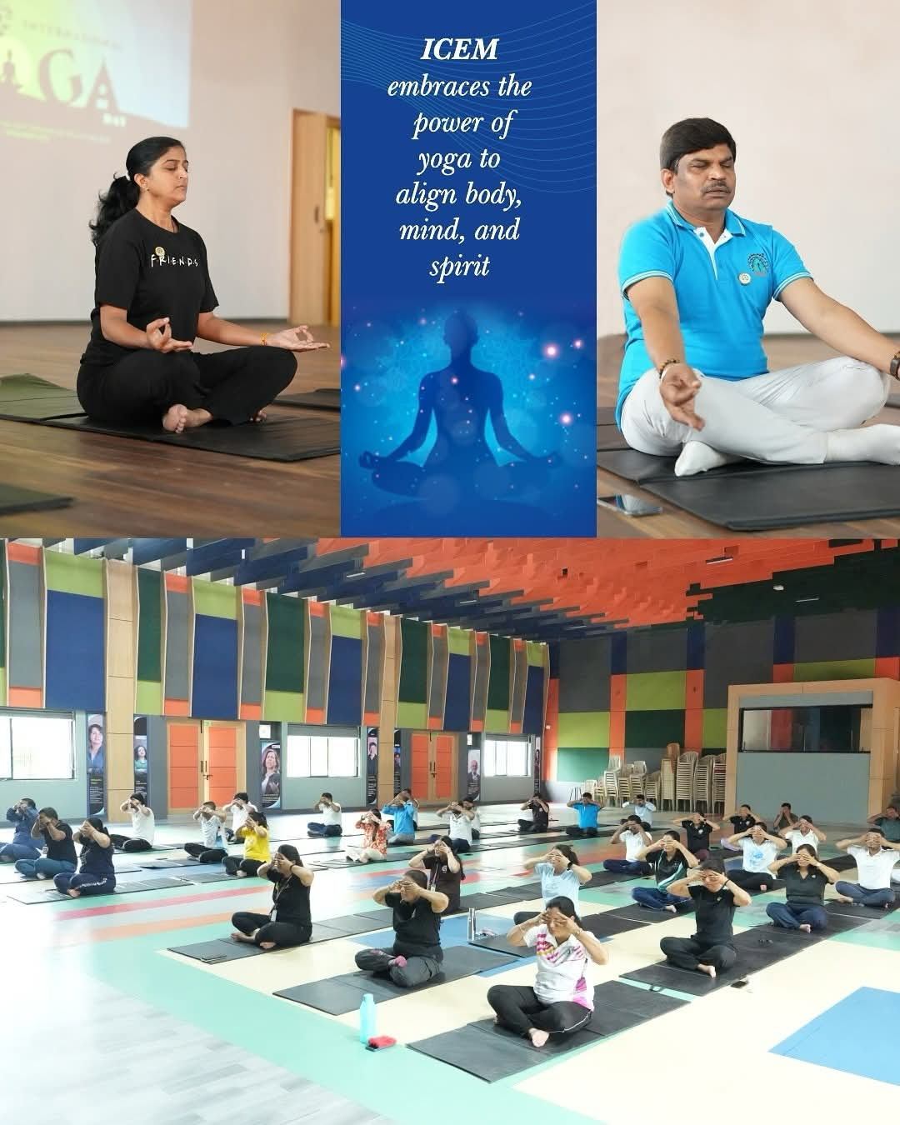
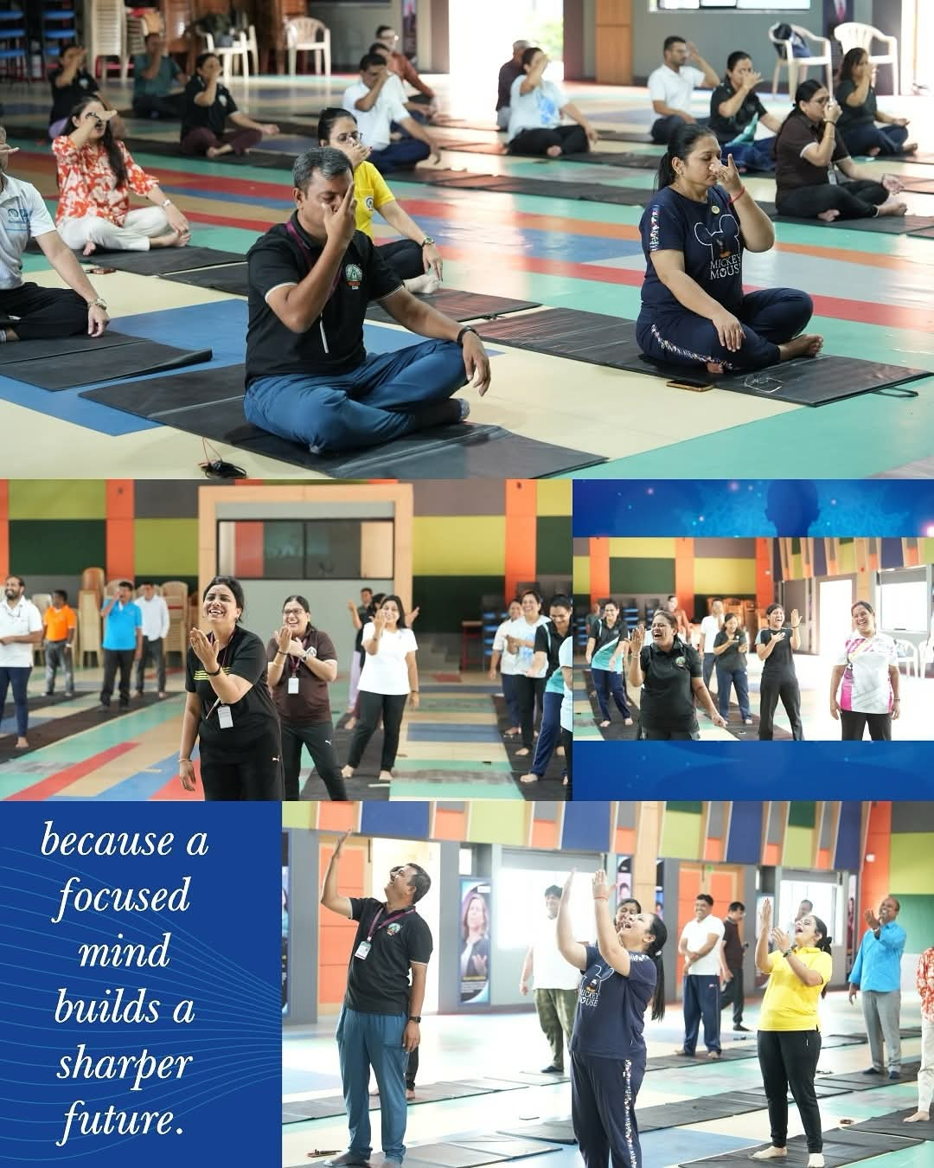
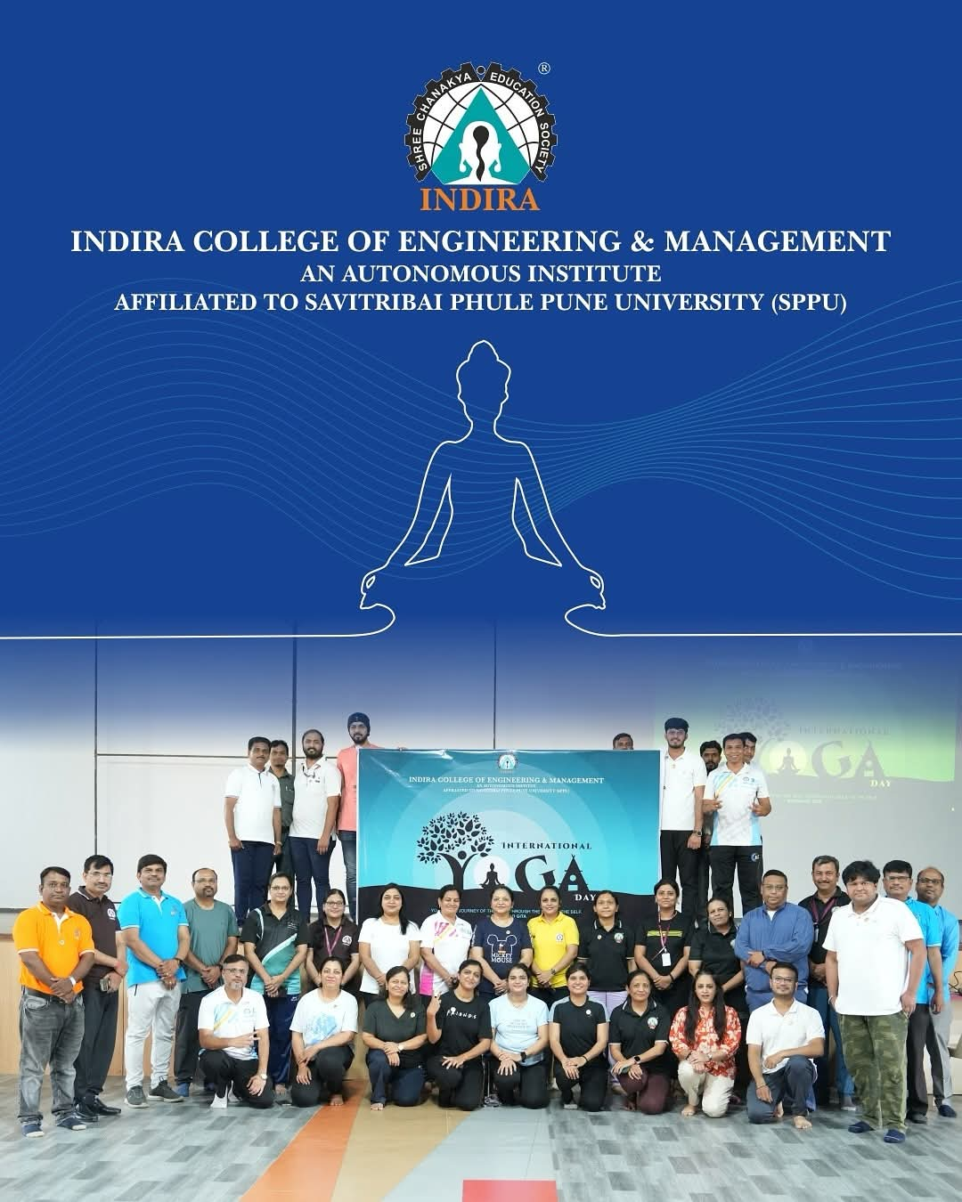

Prof.Reshma Kohad Dr. Nilesh Uke
Cultural Coordinator Principal, ICEM

